**DAILY ONLINE ACTIVITIES SUMMARY**

|  |  |  |  |  |  |  |  |  |
| --- | --- | --- | --- | --- | --- | --- | --- | --- |
| **Date:** | **15/06/2020** | | | | | **Name:** | **POOJA D S** | |
| **Sem & Sec** | **4th Sem 'B' Section** | | | | | **USN:** | **4AL18CS056** | |
| **Online Test Summary** | | | | | | | | |
| **Subject** | | **……** | | | | | | |
| **Max. Marks** | | **30** | | **Score** | | | **……** | |
| **Certification Course Summary** | | | | | | | | |
| **Course** | **Introduction to Ethical Hacking** | | | | | | | |
| **Certificate Provider** | | | **Great Learning Academy** | | **Duration** | | | **4 hour** |
| **Coding Challenges** | | | | | | | | |
| **Problem Statement:** A user will input two strings, and we find if one of the strings is a sub sequence of the other. Program prints “yes” if either the first string is a sub sequence of the second string or the second string is a sub sequence of the first string. Assume that, the length of the first string is smaller than or equal to the length of the second string. Assume that, the length of the first string is smaller than or equal to the length of the second string. | | | | | | | | |
| **Status: completed** | | | | | | | | |
| **Uploaded the report in Github** | | | | | **yes** | | | |
| **If yes Repository name** | | | | | <https://github.com/dspooja/C-coding>  <https://github.com/dspooja/Java-coding> | | | |
| **Uploaded the report in slack** | | | | | **yes** | | | |

Online Test Details: (Attach the snapshot and briefly write the report for the same)

Certification Course Details: (Attach the snapshot and briefly write the report for the same)

Coding Challenges Details: (Attach the snapshot and briefly write the report for the same)

CERTIFICATION COURSE DETAILS:

* My Certification Course is **Introduction to Ethical Hacking**
* **The concepts covered in Introduction to Ethical Hacking are:**
* What is Ethical Hacking

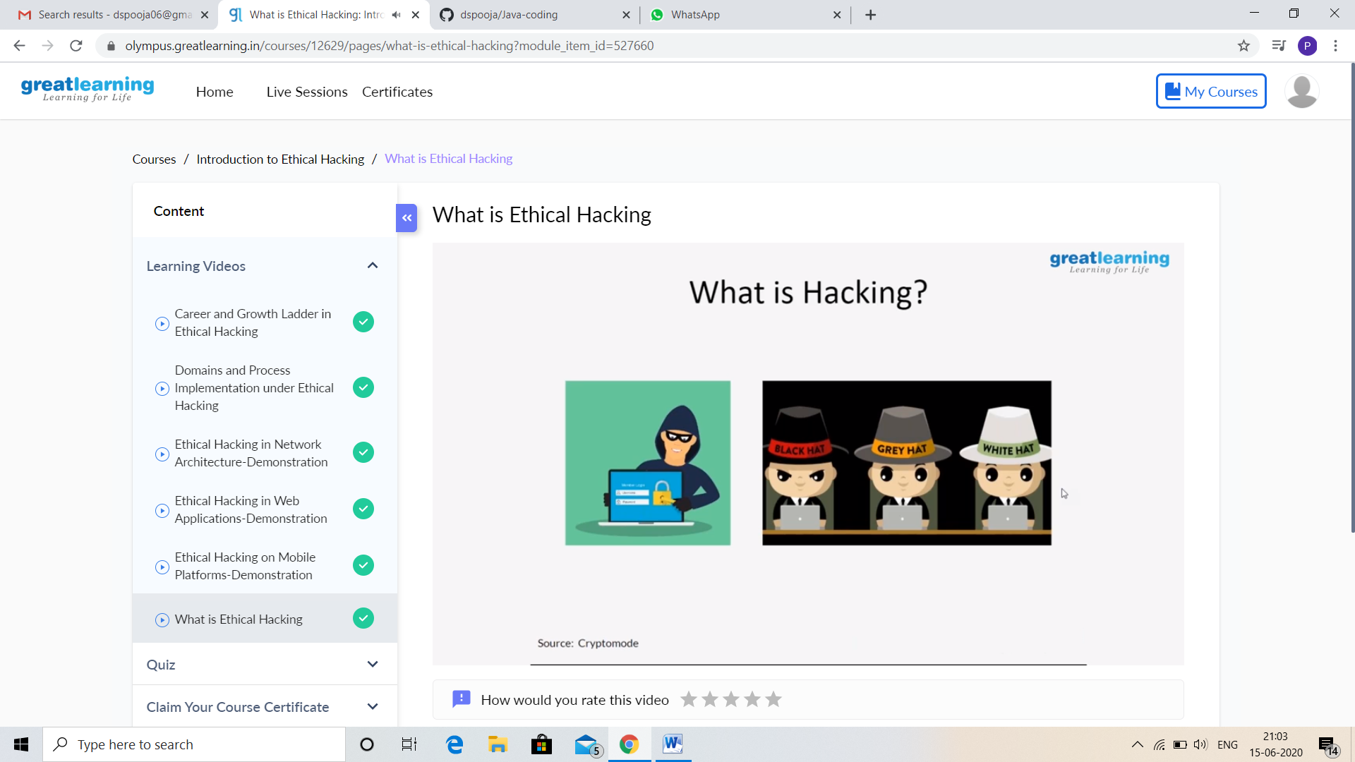

And I attend quiz. I got good Experience. And this is my certificate

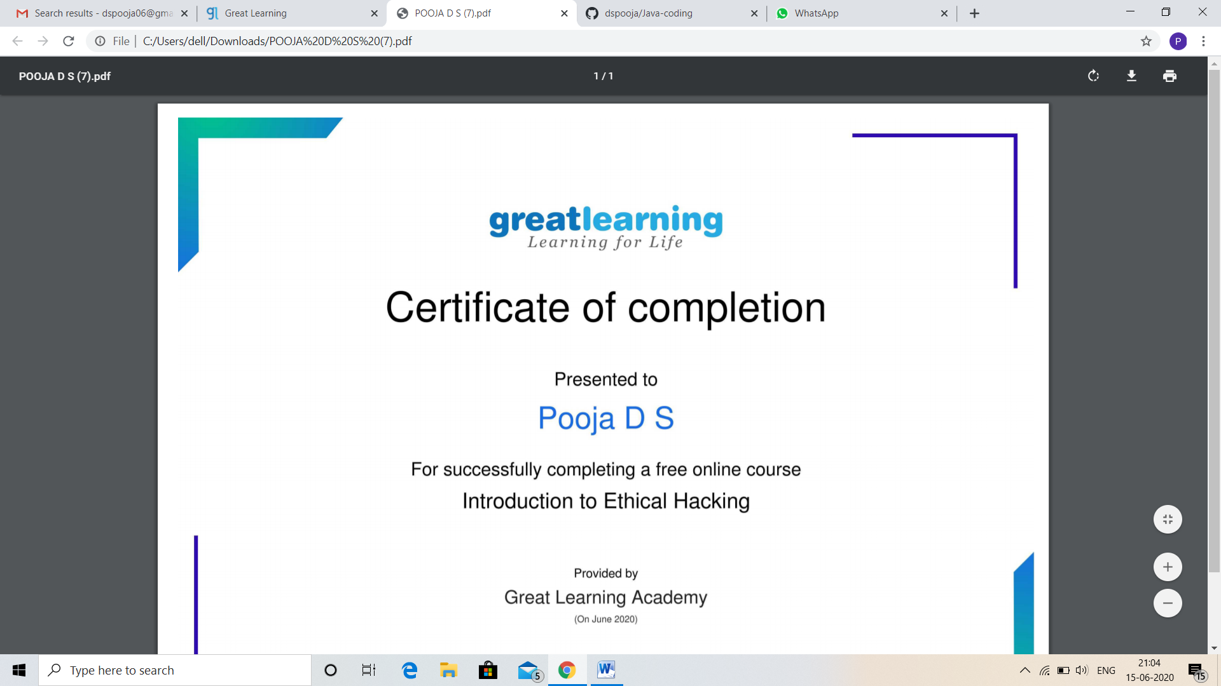

CODING CHALLENGES DETAILS:

Problem statement 1:

Write a Java Program to find if string is K-Palindrome or not.

A string is k palindrome if it can be transformed into a palindrome on removing at most k characters from it. Your task is to complete the function is_k_palin which takes two arguments a string str and a number N . Your function should return true if the string is k palindrome else it should return false.

Input:  
The first line of input is an integer T denoting the number of test cases . Then T test cases follow. Each test case contains a string str and an integer N separated by space.

Output:  
The output will be 1 if the string is k palindrome else 0 .

**Example**  
Input: String - abcdecba, k = 1  
Output: Yes  
String can become palindrome by   
removing 1 character i.e. either d or e)

Input: String - abcdeca, K = 2  
Output: Yes  
Can become palindrome by removing  
2 characters b and e.

Input: String - acdcb, K = 1  
Output: No String can not become palindrome by  
removing only one character.

Solution: Uploaded in github.

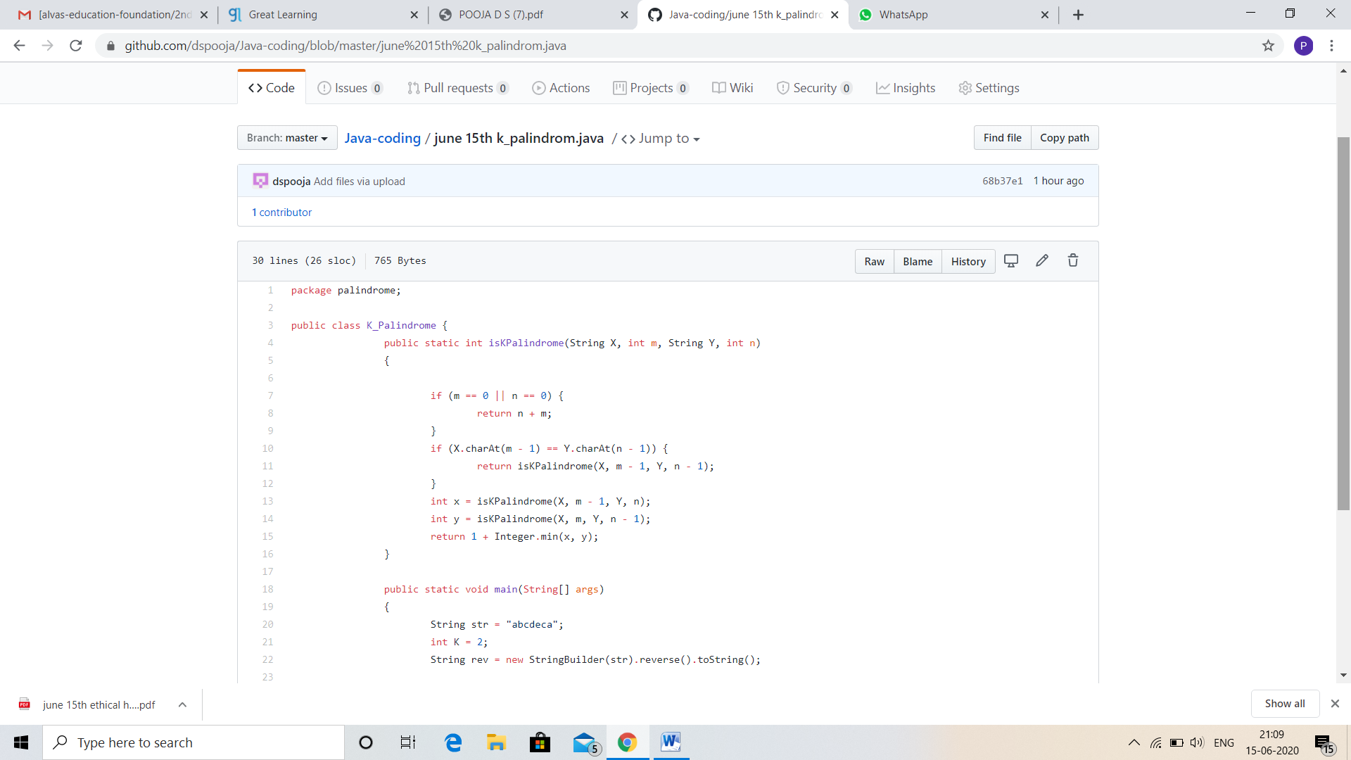

Problem statement 2:

TRIPLY LINKED LIST DESCRIPTION. Programming Question will be Posted Tomorrow.

Solution: Uploaded in github.

